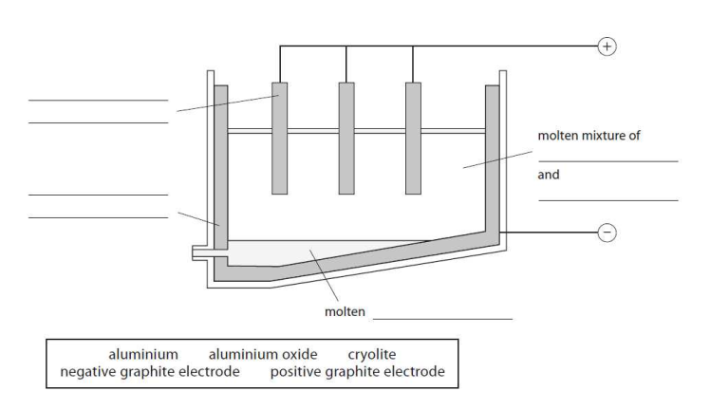
Electrolysis of Aluminium oxide Al₂O₃

Before adding to the cell, Al₂O₃ is mixed with to lower its .

A layer of around the inside of the cell forms the negative electrode. The positive electrodes are also made from graphite.

In the cell, the mixture of Al₂O₃ and cryolite is and a is passed.

Molten Al is formed at the electrode, where the Al³⁺ ions are to Al atoms. The liquid Al runs to the bottom of the cell, where it is tapped off.

At the positive electrode, the O²⁻ ions are and form gas.
The graphite in the positive electrodes with oxygen, producing and so the electrodes must be replaced regularly.

- Half equation at negative electrode:

- Half equation at positive electrode:

Keywords:

graphite oxidised oxygen react carbon dioxide cryolite

melting point current negative reduced melted

