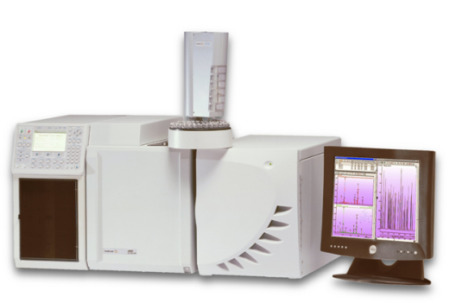
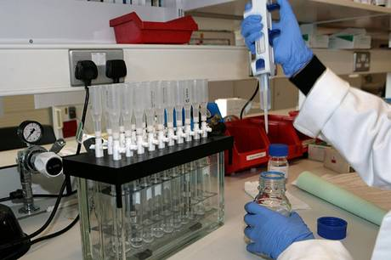
In the London 2012 Olympic Games Belarusian shot-putter Nadzeya Ostapchuk was stripped of her Olympic gold medal after failing a doping test. The first five finishers in every event are tested, plus two at random, immediately after their event, in the venue. In addition, there is random, unannounced testing, in the Olympic Village or wherever athletes are based during Games period. Gas chromatography (GC) and mass spectrometry (MS) are two instrumental methods of analysis. They can be linked together as GC-MS to allow substances in a sample to be separated, and then identified. GC-MS can detect and identify compounds in tiny amounts of a sample, e.g. detecting the presence of banned drugs in samples from athletes.
Task: Prepare a short article for the BBC News website explaining how gas chromatography-mass spectrometry is used to detect and identify different compounds in a mixture, for example drugs testing of athletes.

Key words: gas chromatography, mass spectrometry, sample, peak, retention time, relative molecular mass, molecular ion peak,

To get grade | You might:
C | - Describe at least three advantages of using instrumental methods of analysis  - Explain in simple term how gas chromatography separates substances in a mixture
B | As Grade C plus:  - Describe how the gas chromatograph is interpreted  HINT: explain what the number and position of the peaks indicates about the substances in the mixture
A | As Grade B plus:  - Explain how the mass spectrometer can also give the relative molecular mass of each of the substances separated in the column.  HINT: Sketch and label a mass spectrum and show where the molecular ion peak is found
A* | As Grade A plus:  - A detailed explanation of how gas chromatography works, including mobile and stationary phases

Grade ladder:
What is your target grade? Use the grade ladder to help you reach it:

In the London 2012 Olympic Games Belarusian shot-putter Nadzeya Ostapchuk was stripped of her Olympic gold medal after failing a doping test. The first five finishers in every event are tested, plus two at random, immediately after their event, in the venue. In addition, there is random, unannounced testing, in the Olympic Village or wherever athletes are based during Games period. Gas chromatography (GC) and mass spectrometry (MS) are two instrumental methods of analysis. They can be linked together as GC-MS to allow substances in a sample to be separated, and then identified. GC-MS can detect and identify compounds in tiny amounts of a sample, e.g. detecting the presence of banned drugs in samples from athletes.
To get grade | You might:
C | - Describe at least three advantages of using instrumental methods of analysis  - Explain in simple term how gas chromatography separates substances in a mixture
B | As Grade C plus:  - Describe how the gas chromatograph is interpreted  HINT: explain what the number and position of the peaks indicates about the substances in the mixture
A | As Grade B plus:  - Explain how the mass spectrometer can also give the relative molecular mass of each of the substances separated in the column.  HINT: Sketch and label a mass spectrum and show where the molecular ion peak is found
A* | As Grade A plus:  - A detailed explanation of how gas chromatography works, including mobile and stationary phases

Grade ladder:
What is your target grade? Use the grade ladder to help you reach it:

Key words: gas chromatography, mass spectrometry, sample, peak, retention time, relative molecular mass, molecular ion peak,

Task: Prepare a short article for the BBC News website explaining how GC-MS is used to detect and identify different compounds in a mixture, for example drugs testing of athletes.

Indicated below are the criteria you have met:
C | - Describe at least three advantages of using instrumental methods of analysis  - Explain in simple term how gas chromatography separates substances in a mixture | □  □
B | As Grade C plus:  - Describe how the gas chromatograph is interpreted  - HINT: explain what the number and position of the peaks indicates about the substances in the mixture | □  □
A | As Grade B plus:  - Explain how the mass spectrometer can also give the relative molecular mass of each of the substances separated in the column.  - HINT: Sketch and label a mass spectrum and show where the molecular ion peak is found | □  □
A* | As Grade A plus:  - A detailed explanation of how gas chromatography works, including mobile and stationary phases | □

Grade Achieved:

Improvement Targets:
___________________________________________________
___________________________________________________
___________________________________________________

Indicated below are the criteria you have met:
C | - Describe at least three advantages of using instrumental methods of analysis  - Explain in simple term how gas chromatography separates substances in a mixture | □  □
B | As Grade C plus:  - Describe how the gas chromatograph is interpreted  - HINT: explain what the number and position of the peaks indicates about the substances in the mixture | □  □
A | As Grade B plus:  - Explain how the mass spectrometer can also give the relative molecular mass of each of the substances separated in the column.  - HINT: Sketch and label a mass spectrum and show where the molecular ion peak is found | □  □
A* | As Grade A plus:  - A detailed explanation of how gas chromatography works, including mobile and stationary phases | □

Grade Achieved:

Improvement Targets:
___________________________________________________
___________________________________________________
___________________________________________________

