**Gas chromatography information sheet C2 3.8c**

Instrumental methods of analysis are accurate, sensitive and rapid. They are particularly useful when the amount of a sample is very small.

Chromatography is a technique for separating a mixture of compounds. It is dependent upon a compound distributing itself between two phases, the mobile phase and stationary phase. Different compounds pass through the mobile phase at different speeds, depending on how soluble they are in the stationary phase.

**Paper chromatography**: mobile phase is the solvent (e.g. water) and the stationary phase is the paper.

**Gas chromatography**: The mobile phase is an inert (unreactive) gas such as helium or nitrogen – known as the carrier gas. The stationary phase is a liquid covering the surface of a solid material, packed into a long tube called the column.

**How gas chromatography works**

2. The carrier gas carries the sample through the stationary phase (the liquid). Different substances in the sample mixture travel through the column at different speeds, so that they become separated.

1. A small amount of sample is injected into one end of the heated column, where it turns to vapour (gas)

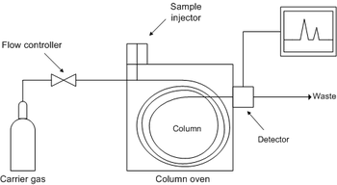

3. The detector records the arrival of each chemical from the column. The number of peaks on the output of a gas chromatograph shows the number of compounds present

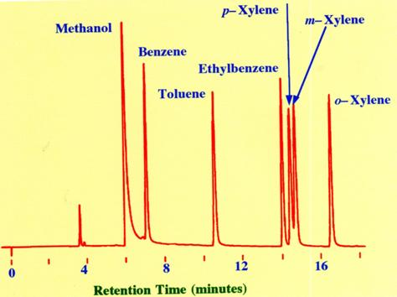

The gas chromatograph looks like this:

* The number of peaks shows the number of compounds present
* The size of the peak shows the relative amount of each chemical present.
* The position of the peaks indicates the retention time – this is the time taken for each component to pass through the stationary phase. Retention time can be used to identify compounds by comparison with retention times of known compounds.

**Mass spectrometry**

The output from the gas chromatography column can be linked to a mass spectrometer, which can be used to identify the substances leaving the end of the column. Mass spectrometry can identify substances very quickly and accurately, and can detect very small quantities.

The mass spectrometer can also give the **relative molecular mass** of each of the substances separated in the column. The molecular mass is given by the **molecular ion peak.** This is the heaviest ion, corresponding to mass of sample molecule with one electron removed. It is always the last peak on the right hand side of the mass spectrum.

Molecular ion peak